a). Fit & state the model

From SAS basic proc reg analysis :
proc reg data = job_scores;
model jobscore = test1 test2 test3 / clb;
run;

The model fit is determined to be :

job_score = b0 + b1 * test_1 + b2 * test_2 + b3 * test_3
job_score = 7.89 + 0.163 * test_1 + 0.410 * test_2 + 0.355 * test_3

The p-value for each of the 3 explanatory variables (tests) are all < 0.05, indicating that each test is significant in estimating the subsequent job score.
The r^2 for the overall regression = 0.77, indicating that 77% of the variation observed in job scores can be explained by the scores on the 3 test scores.

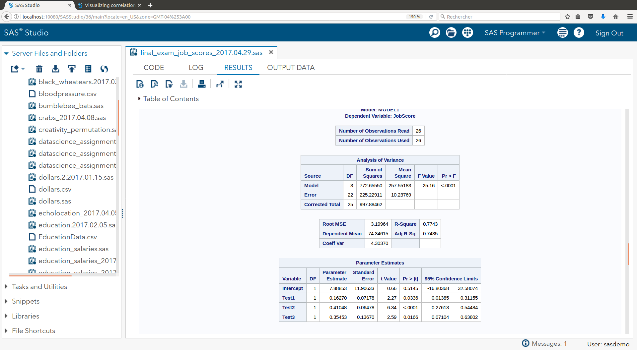

b. ) Are the assumptions of linear regression met ?

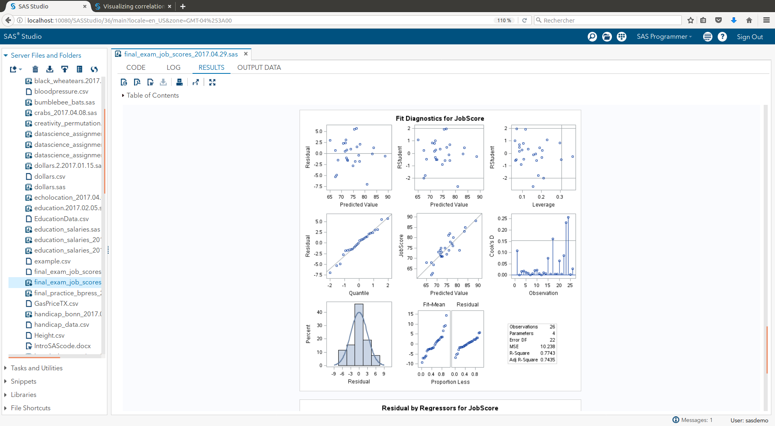 | From the fit diagnostics plots to the left :  - from the QQ plot and histogram of residuals, there is not strong evidence present against normality of the residuals.  - there is not sufficient evidence from the scatter plot of the residuals to suggest non-constant variance conditional on the explanatory variables. there are fewer scores in the range of higher predicted values (>80), and they are visually closer to the 0-residual line, but we will assume that this is due to scarceness of experience in this range, rather than a deviation from constant variance. This is a characteristic to continue to observe as additional experiences with the model is gained (i.e., more observations)  - there is not sufficient evidence against a linear trend in the data judging from the scatter plot of residuals. The distribution of points appears to be sufficiently distributed about 0.  - We will assume the data are independent of one another – given in the problem statement.  - There are three points with Cook’s D values greater than 4/n (4/26 = 0.15), and there is also an observation in the high leverage area. The high Cook’s D observations are 17, 23, and 24. These potentially influential observations are associated to observations with, for instance, lowest test_2 scores and job_scores, while test_1 and test_3 scores are approx average. There is not obviously any recording error (histograms of each individual test scores do not show any significant outliers – see adjacent figure), so we will leave these values in the model unless additional information is provided to suggest otherwise.
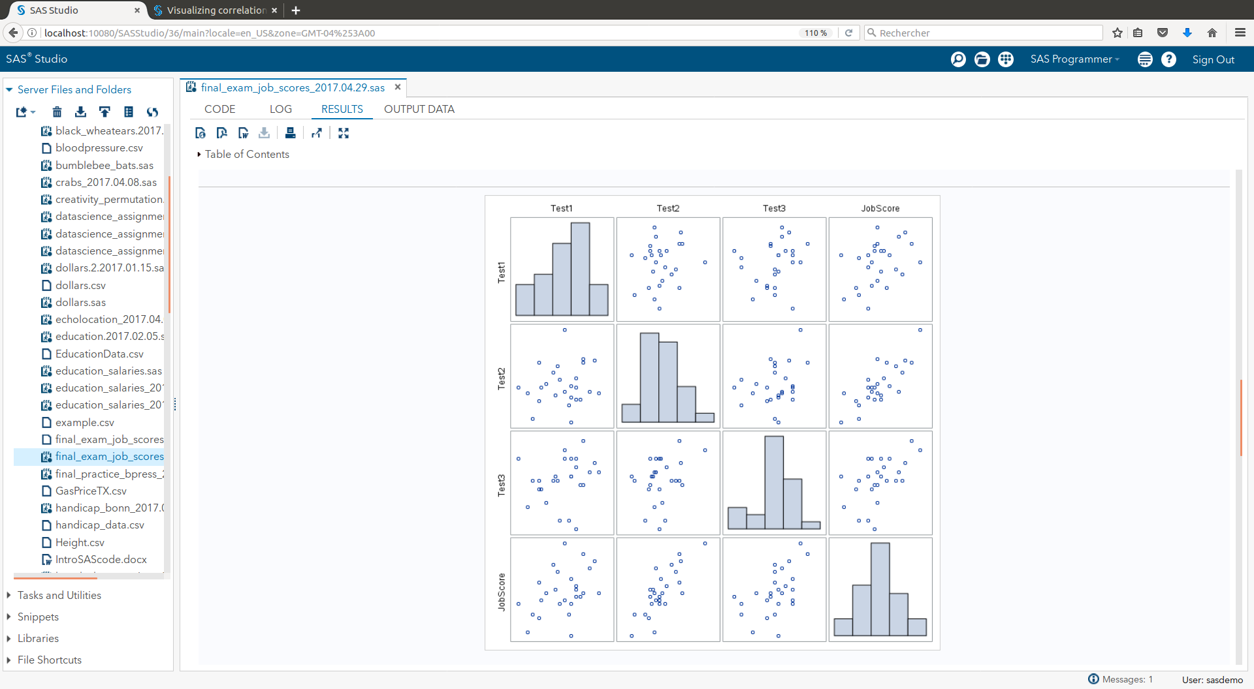
review individual distributions for high influential observations

c.) Interpret the slopes for Test_1 :

Slope : for each increase in the Test_1 score that was received prior to hiring, the job score after one year of employment is expected to = 0.163 points.

d.) predicted job score for an applicant with test scores of (58, 67, 89)

The 95% prediction interval for a job applicant with the above test scores, from this model, is : (69.1, 83.7)

This was determined from an updated SAS proc reg with added observed observation. See images below from SAS output and code.
added observation 1 (58, 67, 89) | prediction interval outputs, observation 1 is for the requested model result
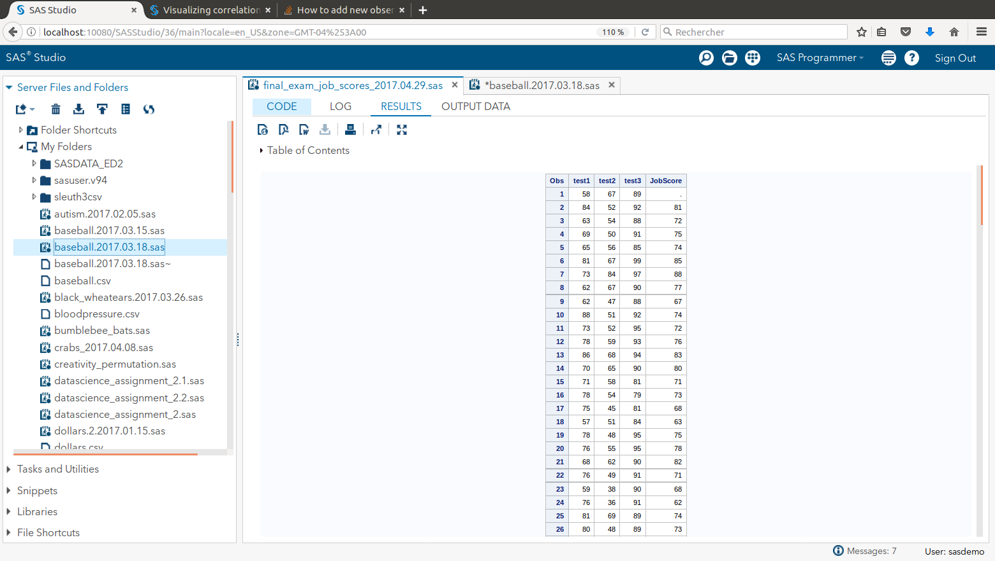 | 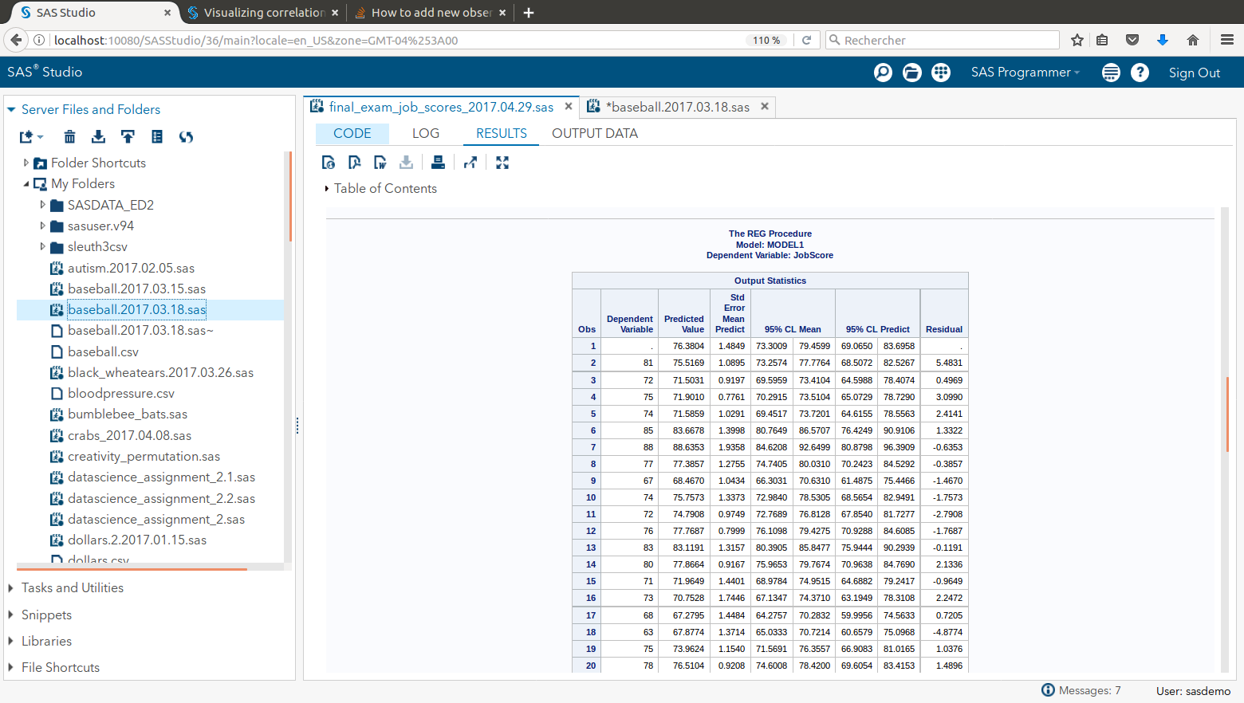
/* add predictor for new obs*/  data job_scores_temp;  input test1 test2 test3;  datalines;  58 67 89  ;  run;  Data job_scores2;  set job_scores_temp job_scores;  run;  … continues in next column --> | proc print data = job_scores2; run;  proc reg data= job_scores2;  model jobscore = test1 test2 test3 /CLB CLM CLI;  run; quit;

